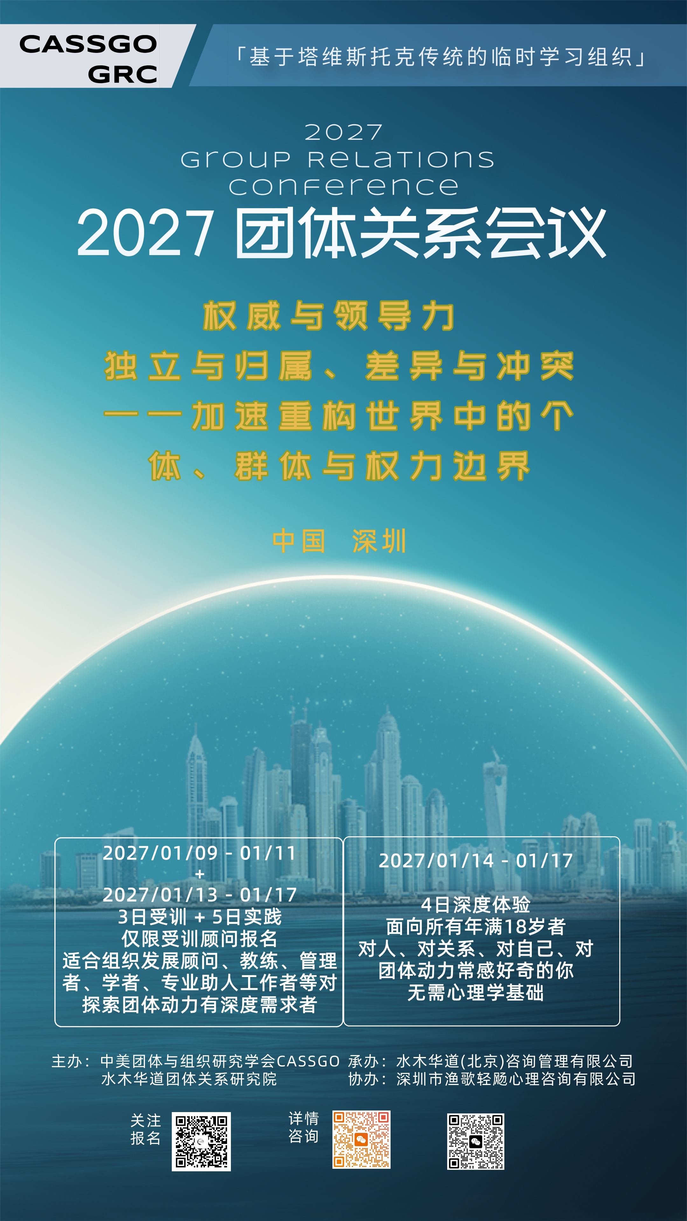

远航、相遇与归来
——变动世界中的个体、群体与关系

尊敬的2027深圳团体关系会议潜在成员：
谨致此信，诚邀您参加2027深圳团体关系会议。
我们生活在一个不断加速变化的时代。
世界的边界正在重新划分，熟悉的秩序不断松动，新的连接不断生成，又不断断裂。技术的发展、社会结构的变化、文化与价值的分化，使我们越来越容易彼此连接，却未必更容易真正理解彼此。
我们一方面比以往任何时候都更强调个体性、独立与自我选择；另一方面，又不断面对一个无法回避的问题：
当我们越来越成为“自己”，我们还能如何成为“我们”？
我们渴望归属，却又害怕被团体吞没；
我们追求独立，却又无法脱离关系而存在；
我们需要差异，却又必须面对差异带来的冲突；
我们不断离开旧的群体与身份，又不断寻找新的连接与共同体。
于是，个体与团体之间那条若隐若现的边界，正在经历一次又一次的拉扯、分化与重构。
我们想起《奥德赛》。
漫长的旅程中，奥德修斯不断离开、遭遇、失去、重建关系，并在一次次与陌生世界的相遇中寻找回家的道路。
我们也想起《给阿嬷的情书》。
当人与故乡相隔、与亲人相隔，甚至与已经逝去的人相隔，关系却并没有因此消失。一封跨越时间与空间的信，使一个人重新进入另一个人的生命，也使个人的生命与家庭、历史、文化和故土重新连接。
远航与归来，也许从来不是两个相反的方向。
离开意味着分化。
相遇意味着差异进入关系。
冲突迫使我们重新理解边界。
我们离开，是为了成为自己；
我们相遇，是因为我们无法独自存在；
我们归来，则意味着带着已经改变的自己，再一次面对关系、团体与共同体。
因此，2027深圳团体关系会议希望邀请来自不同专业、组织与文化背景的朋友，与我们共同进入这样一个开放的问题场：
* 个体与团体之间的张力：我如何保持自己，同时成为团体的一部分？
* 边界与归属：谁是“我们”？边界由谁定义，又如何被改变？
* 差异与分化：当观点、身份、价值和经验越来越不同，我们如何共处？
* 冲突与权力：冲突发生时，我们如何理解其中的权力、依赖与情感？
* 融合与独立：连接是否一定意味着放弃差异？独立是否一定意味着离开关系？
* 变化与重构：当原有结构失去稳定性时，团体如何面对未知？
* 共同体的可能性：在高度分化的时代，我们还能如何共同存在？
这些并非彼此孤立的问题。
它们会在团体的生命过程中相互牵动，并在具体的关系、互动和经验中呈现出来。
团体关系会议所珍视的，恰恰是让问题在关系中发生，让那些通常被隐藏、被压抑、被投射或被理所当然接受的东西，有机会被看见、被体验、被思考。
在这里，我们既是观察者，也是参与者；既带着自己的历史进入团体，也不断受到团体的影响。我们会经历靠近与疏离、认同与拒绝、竞争与合作、依赖与独立，也可能经历困惑、冲突、失望以及意想不到的连接。
一些通常被忽略的情绪和假设，可能开始变得可见。
一些看似属于“别人”的问题，也可能逐渐成为“我们”的问题。
而这些发生在团体中的经验，也许正是我们理解自己，理解当下世界的一面镜子。
深圳是一座特别适合思考这些问题的城市。
它本身就是一座不断“远航”的城市——从边缘走向中心，从本土走向世界，在快速流动的人、资本、技术与文化之间持续重构自身。
因此，我们希望在这座城市相聚，带着各自的故事、经验和问题，暂时放下那些已经熟悉的答案，共同进入一段未知的旅程。
也许我们无法预知这次航行将把我们带向哪里。
但我们期待：
在相遇中看见自己，
在差异中看见他者，
在冲突中看见关系，
在分化中重新思考共同体，
并在一次共同的航行之后，重新理解什么是“归来”。
诚挚邀请您加入我们。
期待与您在深圳相遇。
2027深圳团体关系会议全体工作人员
2026年9月
￼
￼
￼
2027 Shenzhen Group Relations Conference
A Voyage, Encounters, and Return

Individuals, Groups, and Relationships in a Changing World
Dear Prospective Participant in the 2027 Shenzhen Group Relations Conference:
We warmly invite you to take part in the 2027 Shenzhen Group Relations Conference.
We live in a time of accelerating change.
The boundaries of the world are being redrawn. Familiar orders are loosening; new connections are continually formed, then broken again. Technological development, shifts in social structure, and the diversification of cultures and values make it easier than ever to connect with one another, but not necessarily easier to understand one another deeply.
On the one hand, we place more emphasis than ever on individuality, independence, and personal choice. On the other, we are repeatedly confronted by an inescapable question:
As we become ever more fully ourselves, how can we still become a “we”?
We long to belong, yet fear being swallowed up by the group;
We seek independence, yet cannot exist outside relationship;
We need difference, yet must face the conflicts it brings;
We keep leaving old groups and identities, while continuing to search for new connections and communities.
The subtle boundary between the individual and the group is therefore being pulled, differentiated, and remade again and again.
We are reminded of The Odyssey.
Throughout his long journey, Odysseus repeatedly leaves, encounters, loses, and rebuilds relationships. In his encounters with unfamiliar worlds, he keeps searching for a way home.
We are also reminded of A Love Letter to Grandma.
When people are separated from their hometown, their loved ones, or even those who have died, relationships do not simply disappear. A letter across time and distance allows one person to re-enter another’s life, reconnecting an individual life with family, history, culture, and homeland.
Perhaps setting sail and returning have never been opposite directions.
Leaving means differentiation.
Encountering means that difference enters relationship.
Conflict compels us to understand boundaries anew.
We leave in order to become ourselves;
We encounter one another because none of us can exist alone;
We return when, changed by the journey, we face relationship, groups, and community once more.
The 2027 Shenzhen Group Relations Conference therefore invites people from diverse professional, organisational, and cultural backgrounds to enter with us an open field of inquiry:
• The tension between individual and group: How can I remain myself while also becoming part of a group?
• Boundaries and belonging: Who are “we”? Who defines the boundary, and how can it change?
• Difference and differentiation: As views, identities, values, and experience become ever more diverse, how can we live together?
• Conflict and power: When conflict occurs, how might we understand the power, dependency, and emotion within it?
• Integration and independence: Does connection necessarily mean giving up difference? Does independence necessarily mean leaving relationship?
• Change and reconstruction: When existing structures lose their stability, how can groups meet the unknown?
• The possibility of community: In a highly differentiated age, how can we still exist together?
These are not isolated questions. They affect one another throughout the life of a group and take form in concrete relationships, interactions, and experience.
What a Group Relations Conference values is precisely the opportunity for questions to emerge in relationship, allowing what is usually hidden, repressed, projected, or simply taken for granted to be seen, experienced, and thought about.
Here, we are both observers and participants;
we enter the group with our own histories and are continually affected by the group;
we may experience closeness and distance, identification and rejection, competition and cooperation, dependence and independence, as well as confusion, conflict, disappointment, and unexpected connection.
Some emotions and assumptions that usually go unnoticed may begin to become visible. Some issues that seem to belong to “others” may gradually become issues for “us”.
These experiences in the group may offer a mirror through which to understand ourselves and the world we inhabit.
Shenzhen is a particularly fitting city in which to consider these questions.
It is itself a city continually setting sail: moving from the margins to the centre, from local to global, and constantly remaking itself amid the rapid movement of people, capital, technology, and culture.
We hope to gather in this city, each bringing our own stories, experience, and questions. For a time, we will set aside familiar answers and enter an unknown journey together.
Perhaps we cannot know where this voyage will take us.
Yet we hope:
to see ourselves in encounter,
to see others in difference,
to see relationship in conflict,
to rethink community in differentiation,
and, after a shared voyage, to understand anew what it means to “return”.
We warmly invite you to join us.
We look forward to meeting you in Shenzhen.
All Staff of the 2027 Shenzhen Group Relations Conference
September 2026

原理与目标 在体验中学习
团体关系模式以心理动力学为理论基础，用于理解团体、组织及更大的社会系统，聚焦于探索和分析团体作为一个整体所产生的无意识过程，并鼓励成员从此时此地的体验中学习。
要成为有效的领导者并有意义地行使权力需要的不仅仅是智力和技巧层面的理解，还需要对瞬息万变的整体动力层面的解决和把握的能力。
此次会议提供了一个被明确定义的环境，来检验在此时此地所发生的团体层面的力量和动力。由于成员来自不同的团体、家庭和社会系统，他们在会议中所展现的思维、情感和行动将带来各种不同的意义。而这些个人意义的交汇又会反过来影响我们的现实生活，影响我们在团体、学校、组织、机构、社区和社会中所拥有的身份、角色和权力。
成员将有机会直接体验：
🔸如何融入团体，对权力的态度，自己在团体中拥有怎样的角色和声望
🔸协助还是阻挠团体任务的进行
🔸 在团体中如何行使自己的权威、权力和影响力——包括当领导者和追随者
🔸 团体整体如何共谋着创造出"困境"
🔸 如何从适应不良的角色中跳脱出来
会议使命：这不是一场传统培训，而是一次意识进化的「团体炼金术」
在不确定中锚定领导力的本源
🔸 深度沉浸：多个模块环环相扣，构建「觉察-解构-整合-应用」的完整闭环；
🔸 跨维诊断：顾问全程护航，助你捕捉团体无意识中的权力暗码与领导力盲区；
🔸 长效赋能：鼓励同一机构组队参与，会后可定制「组织动力优化方案」，让学习成果穿透会议现场，重塑真实职场生态。
如果你有隶属于同一单位的同伴一起来参加会议，学习的成果和会后的实践将会更加有效！

Principles and Objectives
Learning through Experience

The Group Relations Model is grounded in psychodynamic theory. It helps us understand groups, organizations and broader social systems, focusing on exploring and analysing unconscious processes generated by the group as a whole, and encourages members to learn from here-and-now experiences.

To become an effective leader and exercise power meaningfully requires more than intellectual and technical understanding. It also demands the capacity to grasp and respond to rapidly shifting systemic group dynamics.

This conference provides a clearly bounded setting to examine group forces and dynamics unfolding in the here and now. As members come from different groups, families and social systems, the thoughts, feelings and actions they display during the conference carry diverse meanings. The convergence of these individual meanings, in turn, shapes our real lives, and influences our identities, roles and power within groups, schools, organizations, institutions, communities and society.

Members will have the opportunity for direct experiential learning:
🔸 How to engage with a group, one’s attitudes toward power, and the role and standing one holds within the group
🔸 Recognising whether one supports or obstructs the group’s task
🔸 How to exercise authority, power and influence within the group — both as leaders and followers
🔸 How the group as a whole colludes to create “stuck situations”
🔸 How to step out of maladaptive roles

## Conference Mission: This is not conventional training, but a group alchemy for the evolution of consciousness

To anchor the essence of leadership amid uncertainty
🔸 **Deep Immersion**: Interconnected modules form a complete learning cycle: *Awareness – Deconstruction – Integration – Application*.
🔸 **Multi-dimensional Diagnosis**: Consultants accompany participants throughout, helping them detect hidden power dynamics and leadership blind spots within the group unconscious.
🔸 **Sustained Empowerment**: Teams from the same organization are encouraged to attend together. Customized organizational dynamics optimization programmes can be developed after the conference, enabling insights to extend beyond the event and reshape real workplace ecosystems.

Learning outcomes and post-conference implementation will be far more powerful if you attend alongside colleagues from your organization!

本期特别设计
「成为团体关系会议顾问的完整路径」
与往期不同，本期 GRC 为有志于成为团体关系会议顾问的受训者，特别设计了一条完整的学习路径：
🔸 由二位超过20年团体关系会议顾问经验的国际培训师亲自带领独立的三天专项培训。系统学习顾问工作的理论基础、角色定位与工作方法。
🔸再进入一天工作会议的研讨环节，在真实场域中初步实践。
🔸最后，带着受训中的觉察，完整投入四天的大会，以受训顾问的身份在团体现场中工作与学习——实践对团体动力的观察方法、顾问姿态与干预经验。
🔸与往期受训顾问培训的"会中观摩+培训"模式根本不同之处——八天，从专项培训到观摩实战，独立、深浸的一段完整的从经验中学习之旅。
🔸如果您是组织发展从业者、企业管理者、心理咨询与团体动力方向的研究者，如果您期待的不只是"理解团体"，而是学习"作为顾问进入团体"——这八天，专为这样的你而设。
Special Design for This Programme
A Complete Pathway to Becoming a Group Relations Conference Consultant
Unlike previous programmes, this GRC offering has been specially designed as a full learning pathway for trainees aspiring to become Group Relations Conference consultants:
🔸 Led by two international trainers with over 20 years of experience as Group Relations Conference consultants, this standalone three-day intensive training systematically covers the theoretical foundations, role definition and working methodologies of consultancy practice.
🔸 Trainees then join a one-day working conference seminar for initial practice within a real container.
🔸 Finally, bringing insights gained during the training, participants fully engage in the four-day main conference, working and learning on-site as trainee consultants — practising observation skills for group dynamics, the consultant stance, and intervention approaches.
🔸 Fundamentally different from the “in-conference observation plus training” model used in prior trainee consultant programmes: this eight-day immersive journey spans specialised training, observation and hands-on practice, forming an independent, deep experiential learning process.
🔸 If you are an organisation development practitioner, corporate manager, counsellor, or researcher specialising in group dynamics, and if your goal goes beyond merely “understanding groups” to learning how to “enter a group as a consultant” — these eight days are designed specifically for you.

结构与方法
在边界中沉浸体验
会议旨在帮助成员学习如何在团体中行使权威，并帮助成员理解他们在运用和应对权威时的体验和反应。会议由一系列团体和团体间活动所组成：
开幕式(Opening Plenary, OP):由全体工作人员和全体成员组成，介绍本次GRC的边界、权威、角色与任务，从外部世界过渡到GRC的世界。
小型学习团体(Small Study Group, SSG):由8-12名成员组成，探索小型学习团体发展过程中在此时此地的权威与领导。每个团体会有1-2名顾问来协助团体完成任务。本次会议设多场小型学习团体。
大型学习团体(Large Study Group, LSG):由全体成员和数名顾问组成，探索当面对面的交流沟通受阻时，大团体在此时此地的动力。本次会议设多场大型学习团体。
机构活动(Institutional Event, IE):成员自发发起或加入不同的机构，并与其他成员机构及工作人员机构进行互动。此项活动的主要任务是通过研究机构内部和机构间的关系，来研究系统动力，包括成员机构、顾问机构和管理机构。
回顾应用团体(Review and Application Group, RAG):由5-7名成员和1-2名顾问组成。帮助成员回顾、觉察和思考自己在不同会议活动中的角色和体验，并将学习成果与他们在工作、社区和其他机构中的角色联系起来，本次会议设多场回顾应用团体。
闭幕式(Closing Plenary, CP):由全体工作人员和全体成员组成，消化本次GRC引发的体验和学习，并从GRC的世界回归过渡到外部世界。
请注意：
本次大会旨在为成员提供一个整体性的学习体验。学习的内容不仅是在单项活动中，活动的顺序和架构也是成员学习的内容。因此，我们鼓励成员全身心投入到每一项活动中，勿要缺席（详细的日程安排将在成员完成全部注册程序之后发送到成员邮箱）。

Structure and Methodology
Immersive Experience within Boundaries

The conference aims to help members learn how to exercise authority within groups and understand their experiences and responses when using and contending with authority. The conference consists of a series of group and inter-group events:
Opening Plenary (OP) Comprising all staff and members, this session introduces the boundaries, authority, roles and tasks of this GRC, facilitating the transition from the external world into the world of the GRC.
Small Study Group (SSG) Made up of 8–12 members, the group explores here-and-now authority and leadership as the small study group evolves. Each group is supported by one or two consultants to help the group fulfil its task. Multiple Small Study Groups will be offered at this conference.
Large Study Group (LSG) Composed of all members and several consultants, this session explores the here-and-now dynamics of the large group when face-to-face communication becomes blocked. Multiple Large Study Groups will be held at this conference.
Institutional Event (IE) Members initiate or join different institutions and interact with other member institutions and staff institutions. The primary task of this event is to examine systemic dynamics by studying intra-institutional and inter-institutional relationships, including member institutions, consultant institutions and management institutions.
Review and Application Group (RAG) Formed by 5–7 members together with one or two consultants. It supports members to reflect, become aware of and examine their roles and experiences across different conference events, and connect learnings to their roles at work, in communities and other organisations. Multiple Review and Application Groups will be available at this conference.
Closing Plenary (CP) With all staff and members present, this session helps participants process the experiences and learnings generated throughout the GRC, supporting the transition back from the GRC space to the external world.
Please note: This conference is designed to provide members with a holistic learning experience. Learning arises not only from each individual event; the sequence and architecture of the events themselves also constitute part of members’ learning. Members are therefore encouraged to fully engage in every session and avoid absences. (The detailed schedule will be emailed to members once registration is fully completed.)

组织与支持机构
工作团队
🔸主办方
中美团体与组织研究学会（CASSGO）
水木华道团体关系研究院
🔸承办方
水木华道（北京）咨询管理有限公司
🔸协办方
深圳市渔歌轻飏心理咨询有限公司
🔸合作机构
重庆心生领界健康管理咨询有限公司
千江心理咨询（上海）事务所
苏州心吧文化传播有限公司
童话心语（北京）教育咨询有限公司
（持续更新中，按拼音首字母排序）
🔸工作语言
会场不设专职翻译。所有人员自主自由探索方式实现交流和沟通。
🔸工作团队（详细介绍附后）
会议主任：鲁小华
会议副主任：吕大为
培训副主任：Monica Velarde Lazarte
会议行政助理主任：高安静
大团体顾问组组长：Viera Stenning
大团体顾问：鲁小华、Viera Stenning、颜子豪
小团体顾问组组长：吕玥
小团体顾问：吕大为、吕玥、茆丁、Monica Velarde Lazarte、孙晓峰、王尔东
行政：高安静、张杲霞、周湘

Organising & Supporting Institutions
Working Group
🔸 Organisers China-America Society for the Study of Groups and Organisations (CASSGO)
Shuimu Huadao Institute of Group Relations
🔸 Host
Shuimu Huadao (Beijing) Consulting Management Co., Ltd.
🔸 Co-organiser
Shenzhen Yuge Qingyang Psychological Counseling Co., Ltd.
🔸 Partner Institutions
Chongqing Xinsheng Lingjie Health Management Consulting Co., Ltd. Qianjiang Psychological Counseling (Shanghai) Office
Suzhou Xinba Culture Communication Co., Ltd.
Tonghua Xinyu (Beijing) Education Consulting Co., Ltd.
(List in alphabetical order by Pinyin; to be updated continuously)
🔸 Working Language
No on-site professional interpreters will be provided. All participants are expected to communicate through self-directed methods.
🔸 Working Group (Detailed profiles to follow)
Conference Director: Lu Xiaohua
Deputy Conference Director: Lü Dawei
Deputy Training Director: Monica Velarde Lazarte
Chief Conference Administrative Assistant: Gao Anjing
Large Study Group Consultant Lead: Viera Stenning
Large Study Group Consultants: Lu Xiaohua, Victor Gan, Viera Stenning
Small Study Group Consultant Lead: Lü Yue
Small Study Group Consultants: Lü Dawei, Lü Yue, Mao Ding, Monica Velarde Lazarte, Sun Xiaofeng, Wang Erdong
Administration Team: Gao Anjing, Zhang Gaoxia, Zhou Xiang

会议时间 地点
参会对象
🔸会议时间
普通成员参会：2027年1月14日-17日，4天。
受训顾问参会：2027年1月9日-11日、13日、14日-17日，8天。（12日上午备用）
🔸会议地点
中国 深圳
🔸参会对象
对探索内在权威与领导，外在个人与组织关系，了解组织动力感兴趣的：
• 在家庭和单位中关注到有关权威与领导的动力议题，并想探索的个人
• 企事业单位员工、人力资源工作人员、新任领导、管理者、企业主等
• 心理治疗师、心理咨询师、团体带领者、组织发展顾问等
• 心理学、管理学、社会学、教育学等领域相关工作人员或学生
• 对探索独立与归属、差异与冲突之权力边界感兴趣的相关人士
Conference Dates & Venue
Target Participants
🔸 Conference Dates
General Members: 14–17 January 2027 (4 days).
Trainee Consultants: 9–11 January, 13 January, and 14–17 January 2027 (8 days). (12 January reserved as backup in the morning.)
🔸 Venue
Shenzhen, China
🔸 Target Participants
Those interested in exploring inner authority and leadership, interpersonal and organisational dynamics:
• Individuals who wish to explore authority and leadership dynamics arising within their families and workplaces
• Employees of enterprises and institutions, HR professionals, emerging leaders, managers, business owners, etc.
• Psychotherapists, counsellors, group facilitators, organisation development consultants, etc.
• Practitioners and students in psychology, management, sociology, education and related fields
• Professionals interested in exploring power boundaries around independence and belonging, difference and conflict
注册报名及参会费用
🔸注册报名
🔸报名方式、录取和退出
• 会议成员报名：可扫描下方二维码提交报名表，报名时须上传推荐信，注册人数上限为60名，以缴费为准，请尽早报名。


受训顾问报名：本次会议设置受训顾问席位，有过完整的地面团体关系会议经历，且未来有意愿成为团体关系会议顾问者，可通过扫描下方二维码填写线上报名表。报名时须上传推荐信，名额有限，请尽早报名。

推荐人及推荐信：每位报名者必须填写一位推荐人的姓名和联系方式，并提供推荐信，因为体验式学习有时会给学员带来压力。因此，成员需要具备一定的心理承受力，不建议身体不适或正在经历重大挫折者报名此次会议。这位推荐人必须是一位能够担保报名者参与此次高强度体验式会议之能力的人士（推荐人可以是家人、朋友、同事、督导师或领导等）。 推荐信参考模板详见报名问卷内。
• 录取：会议成员录取通知书将在收到申请的1周内通过邮件发放，受训顾问录取通知书将在1-2周内通过邮件发放，并告知付费方式，优惠条件按成功提交报名表日期计算，须在收到录取邮件通知时间内完成缴费，请注意查收邮件。如未及时缴费，录取名额可能会顺延至下一位合格的报名者。
• 奖学金：本次会议会根据成员的经济情况提供部分奖学金，名额有限。请在收到奖学金通知后，再缴费。扫描下方二维码填写奖学金申请。

• 退出或取消报名：已缴费的报名者若无替补的候选报名者，参会前取消报名，将扣除15%的服务费，参会后取消报名将无法退款。
🔸参会费用
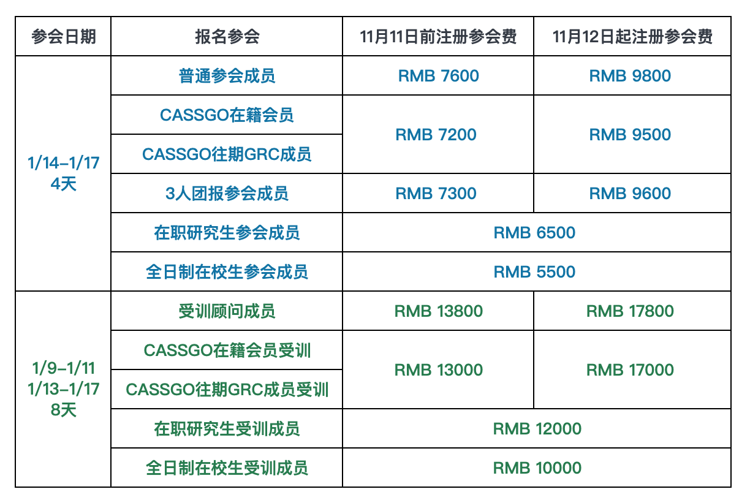
上表中所列日期包含当日内的时间。
• 报名受训顾问须有作为成员完整参加过2次地面团体关系会议的经历，或1次地面团体关系会议+1次地面顾问培训的经历。
• 向在读学生开放有限名额，按提交报名表注册顺序先到先得。
• 本次设有少量奖学金名额，面向非常希望参加GRC的学习，同时经济有压力的成员。
• 以上价格已含税，可开具发票。
✴ 提供帮助✴
感谢你的阅读！
如果你愿意支持本会议运作，分担奖学金成本，帮助经济情况比较困难的人加入团体关系会议中学习，可捐款帮助，金额随己。
如果你在国内，有微信能扫码，可扫描下方二维码进行登记和捐助；

如果你在国内，不方便扫码，可写邮件给cassgo2019@163.com进行登记和捐助；
如果你在海外，可通过Paypal支付至：gaoanjing.psy@foxmail.com
我们会持续更新将历年来提供帮助者信息公布到cassgo网站和公众号中，以表感谢。
🔸报名截止时间
11月11日前，享早鸟价参会；
11月12日起，享标准价参会。
以上均按成功提交报名表日期为准。
🔸住宿
此次参会费用不包括住宿费用。会议酒店会为成员住宿提供最优惠折扣，具体折扣价另行通知。
🔸联系方式
如有疑问或需要帮助，请发送邮件至cassgogrc2014@163.com。或者添加行政人员微信进行咨询:


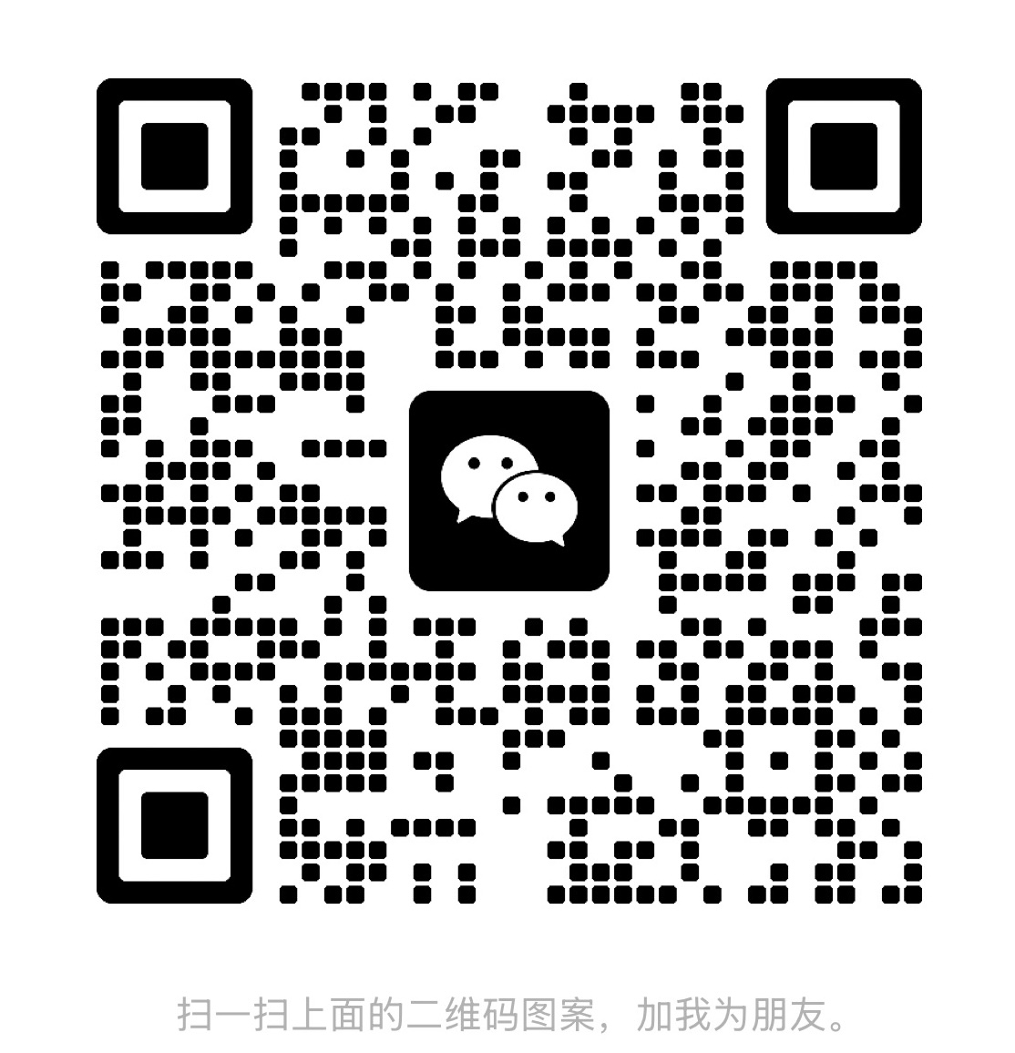

Conference Registration and Fees
Conference Registration

Registration, Admission and Withdrawal
• Registration for conference members: Please scan the QR code below to submit the application form. A reference letter is required at the time of application. The maximum capacity is 60 participants. Admission is confirmed upon payment. Please register early.
• Trainee consultant positions are available for this conference. Those who have completed an in-person Group Relations Conference and aspire to become Group Relations Conference consultants in the future may fill out the online application form by scanning the QR code below. A reference letter must be submitted together with the application. Spots are limited; please apply early.
Referee and Reference Letter: Each applicant must provide the name and contact information of one referee and submit a reference letter. Experiential learning can at times be stressful for participants. Members therefore need a certain level of psychological resilience. Those in poor physical health or undergoing major life setbacks are not recommended to apply for this conference. The referee must be someone who can vouch for the applicant’s capacity to participate in this high-intensity experiential conference (referees may include family members, friends, colleagues, supervisors, leaders, etc.). The reference letter template is available within the registration questionnaire.
• Admission: Admission notifications for conference members will be sent by email within one week of application receipt. Admission notifications for trainee consultants will be emailed within 1–2 weeks, together with payment instructions. Discount eligibility is determined by the date the completed application form is submitted. Payment must be made within the time frame specified in the admission email. Please check your inbox regularly. Failure to complete payment on time may result in your place being offered to the next qualified applicant.
• Scholarships: A limited number of partial scholarships are available for participants based on financial need. Please wait for scholarship approval notification before making payment. Scan the QR code below to submit your scholarship application.
• Withdrawal or Cancellation: For applicants who have completed payment, if there is no waitlisted substitute candidate, a 15% service fee will be deducted for cancellations made before the conference. No refunds will be granted for withdrawals after the conference starts.

Conference Fees

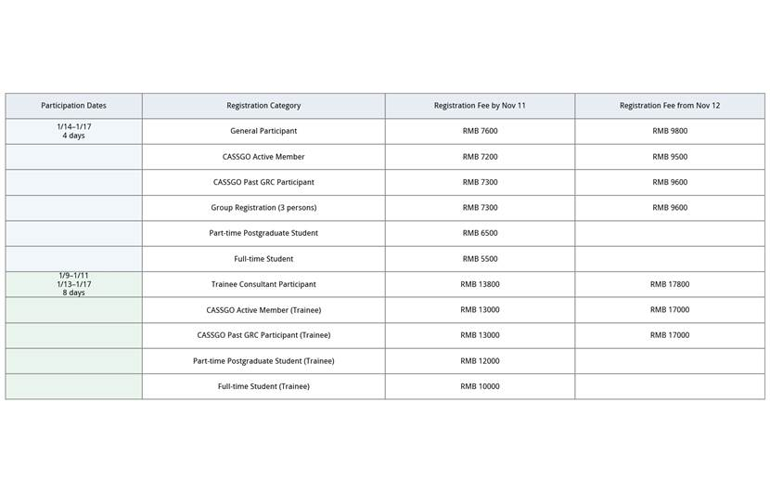
• The dates listed in the table above include the respective days.
• Applicants for the Trainee Consultant track must have fully participated in 2 in-person Group Relations Conferences as members, OR 1 in-person Group Relations Conference plus 1 in-person consultant training programme.
• A limited number of spots are available for currently enrolled students, allocated on a first-come, first-served basis upon submission of registration forms.
• A small number of scholarships are available for participants with strong motivation to join the GRC study and facing financial constraints.
• All fees stated above are tax-inclusive and invoices can be issued.
✴ Offer Support ✴
Thank you for reading!
If you wish to support the operation of this conference, share the cost of scholarships and help participants with limited financial means to join and learn at the Group Relations Conference, you are welcome to make a donation of any amount.
If you are located in China and have access to WeChat, please scan the QR code below to register and donate.
If you are in China and cannot scan the QR code conveniently, you may email cassgo2019@163.com to complete registration and donation.
If you are overseas, you may pay via PayPal to: gaoanjing.psy@foxmail.com
We will continuously update and publish the list of donors on the CASSGO website and WeChat official account as an expression of gratitude.
🔸 Application Deadline Early-bird rates apply for applications submitted on or before November 11. Standard rates apply for applications submitted from November 12 onwards. All rates are determined by the date your completed application form is successfully submitted.

🔸 Accommodation
Conference fees do not cover accommodation. The conference hotel will offer members the best available discounted rates. Specific pricing will be announced separately.
🔸 Contact Information
For enquiries or assistance, please email cassgogrc2014@163.com. You may also reach our administrative staff via WeChat:

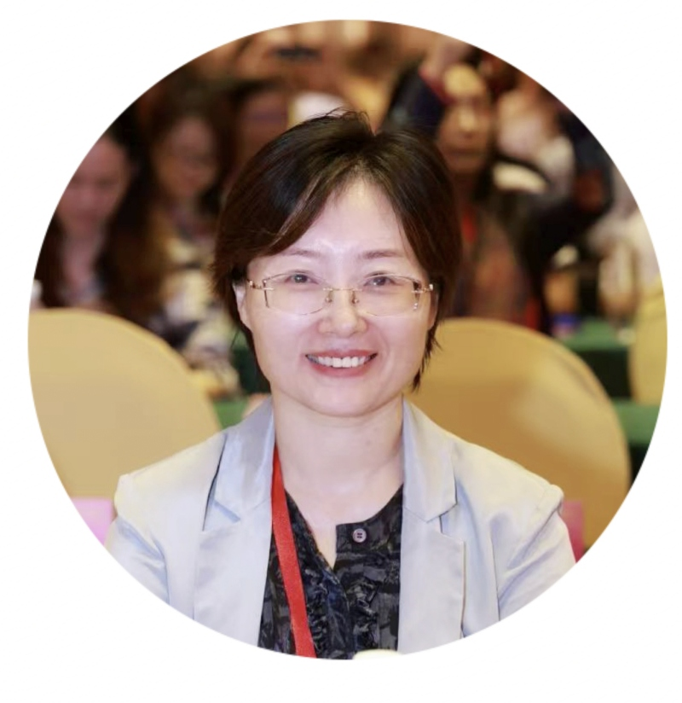
会议主任、大团体顾问 鲁小华 博士
北京交通大学心理中心教授，中国心理学会临床注册督导师，美中国际心理学院认证团体咨询师，AK莱斯社会体系研究所认证团体关系顾问，中国心理卫生协会团体心理辅导与治疗专业委员会副主任委员，中美团体与组织研究学会（CASSGO）理事长。
2016-2020中国人民大学商学院博士后经历，2018-2019芝加哥大学精神和行为神经科学系访问学者。
她代表团体专委会推动了团体关系会议在中国的发展，在中美英都积极参加团体关系会议及相关活动，历任文化翻译，行政，行政助理主任，受训顾问，候任顾问，大小团体观察员，顾问和主任，也发表了多篇团体关系相关文章。
Xiaohua Lu, PhD
Professor, Counseling Center of Beijing Jiaotong University;Certified supervisor of Clinical Psychological Registration System of Chinese Psychological Society; Certified Group Counselor of Sino-American International Psychological College;
Certified Consultant of AKRice Institute of AK Rice Institute for the Study of Social Systems.Associate Director of the Division of Group Counseling and Group Therapy (DGCTG), China Association for Mental Health(CAMH);President of China-America Society for the Study of Groups and Organizations (CASSGO);
From 2016 to 2020, she had a postdoctoral experience at the School of Business, Renmin University of China. From 2018 to 2019, she was a visiting scholar at the Department of Psychiatry and Behavioral Neuroscience of the University of Chicago.She has promoted the development of Group Relations Conferences in China on behalf ofDGCGT, CAMH.She has actively participated in Group Relations Conferences and related activities in China, the United States, and the United Kingdom. She has successively served as a cultural translator, administrator, administrative assistant director, consultant-in-training, consultant candidate, observer of large and small groups, consultant, and director. She has also published several articles related to group relations.

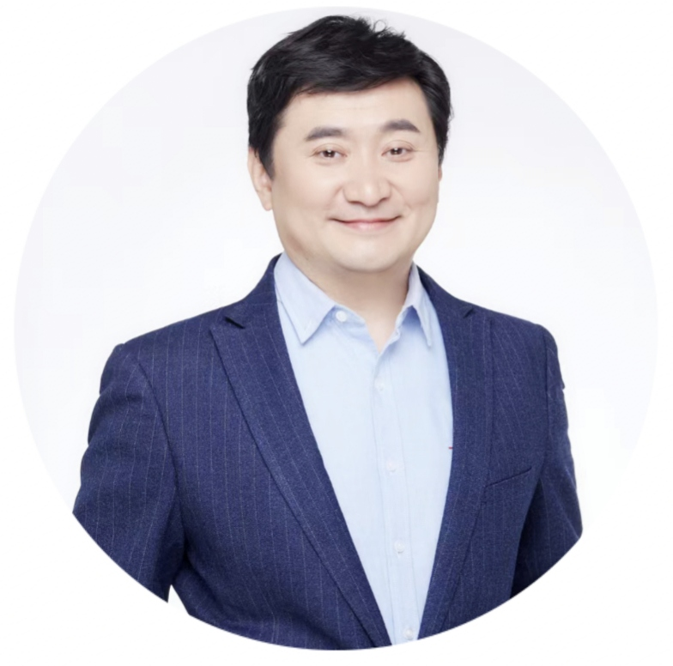
会议副主任、小团体顾问 吕大为
心理学硕士，中国心理学会注册督导师（D-025-203），团体专委会人际动力团体工作组副组长，中国TA(沟通分析心理学)高级应用顾问。多次参加团体关系大会。系统参加团体关系模式的小团体顾问培训和大团体顾问培训，多次担任团体关系会议顾问。
Lyu Dawei
Master of Psychology; Registered Supervisor, Chinese Psychological Society (D-025-203).Deputy Head, Interpersonal Dynamic Group Working Group, Group Psychology Committee.Senior Certified Transactional Analysis (TA) Consultant, China.Frequent participant in Group Relations Conferences; completed systematic training in the Group Relations Model as both Small Group and Large Group Consultant; served multiple times as Consultant in Group Relations Conferences.

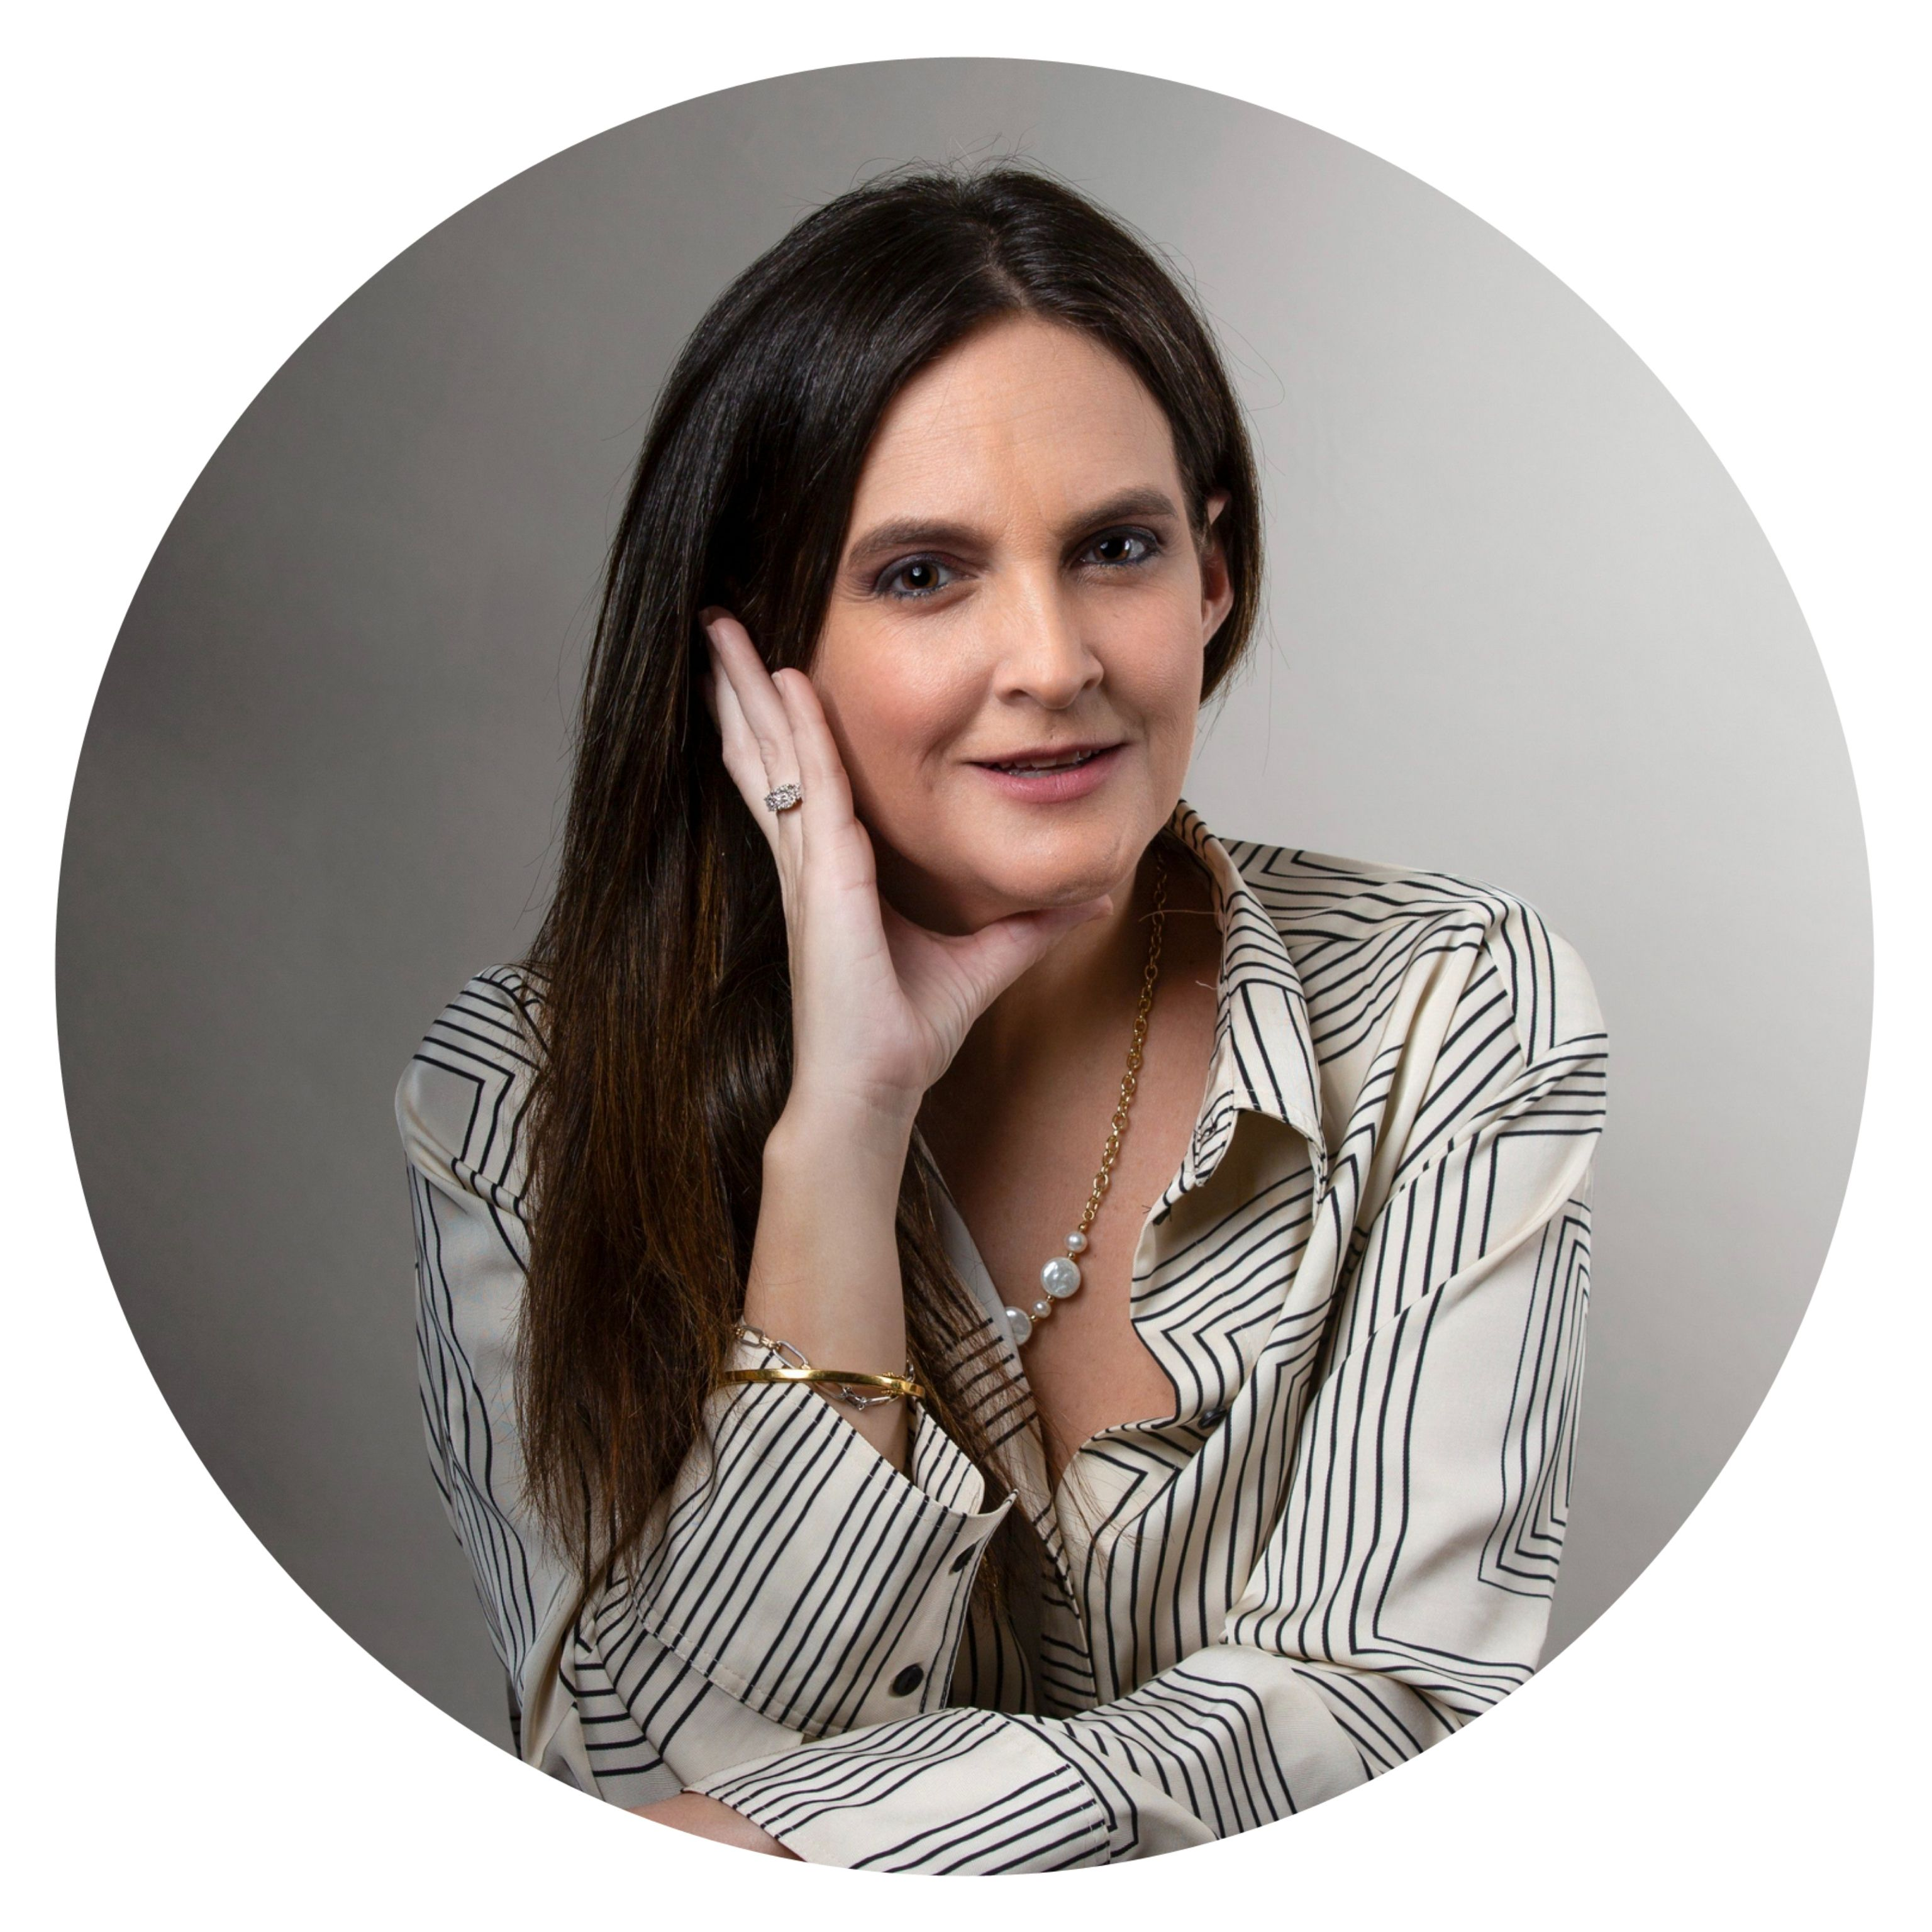
培训副主任、小团体顾问 Monica Velarde Lazarte（英国）
Mónica Velarde Lazarte 博士是一位社会分析师、心理学家与组织顾问，其工作将精神分析洞见、系统思维与伦理想象力融会贯通。她现任塔维斯托克人类关系研究所（Tavistock Institute of Human Relations）理事及专业合伙人，社会分析实践（Socioanalytic Practice）创始主任，并联合创办了“疆域”（The Territory）——一个致力于自由与学习的平台。她被任命为纽约团体、组织与社会系统研究中心（AK Rice 研究所附属中心）2025–2027 年度团体关系大会系列主任。她在设计与主持团体关系会议、组织干预及领导力发展项目方面拥有二十余年经验。目前，她还担任中国团体关系大会培训副主任，将自身在无意识动力、团体关系会议及其实践应用方面的专长，带入这一跨文化学习共同体。
Dr. Mónica Velarde Lazarte is a socioanalyst，psychologist, and organisational consultant whose work bridges psychoanalytic insight, systems thinking, and ethical imagination. A Trustee and Professional Partner of the Tavistock Institute of Human Relations, Founding Director of Socioanalytic Practice, and co-founder of The Territory, a platform for freedom and learning. She is the appointed Director of the 2025-2027 series of Group Relations Conference at the New York Center for the study of groups, organisations and social systems, an affiliated center to the A.K. Rice Institute. She brings over twenty years of experience designing and directing Group Relations Conferences, institutional interventions, and leadership development programmes. She serves as Deputy Director of Training for the Group Relations Conference in China, bringing her expertise in unconscious dynamics and group relations conferences and applications to this cross-cultural learning community.

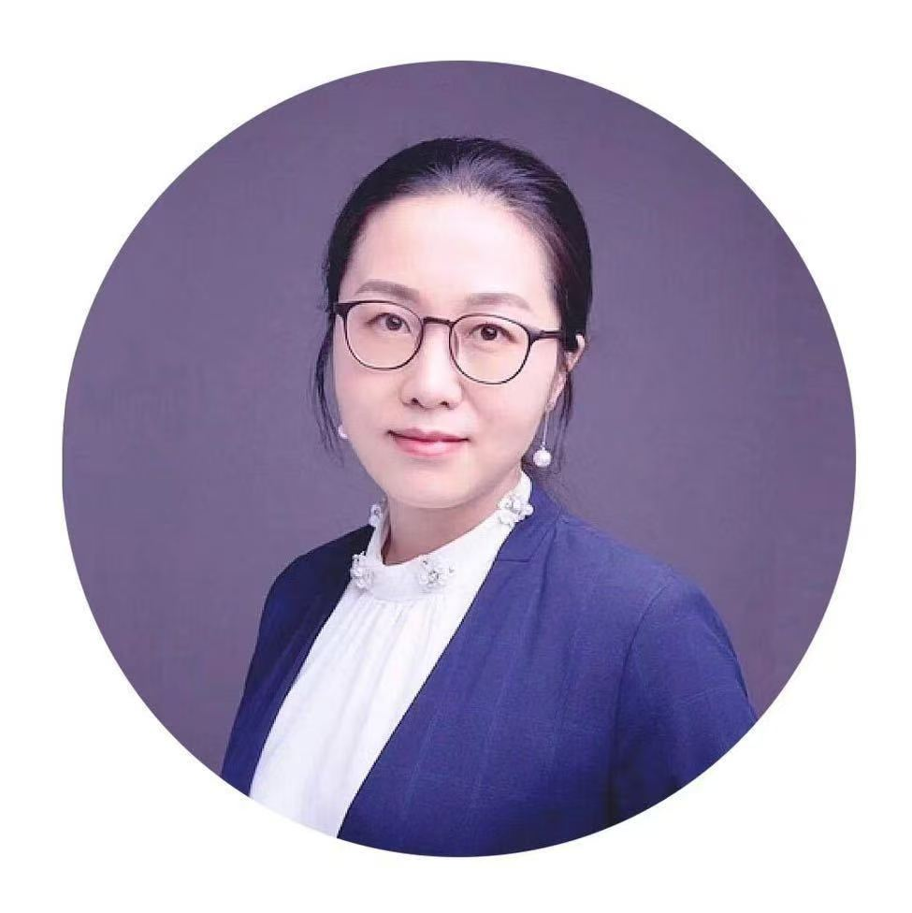
会议行政助理主任 高安静
个人执业心理咨询师，团体咨询师；中科院心理所研究生；中国二级心理咨询师，中国心理学会注册助理心理师；中美团体与组织研究学会理事；自2019年来多次以学员、受训顾问、行政、行政副主任身份参加团体关系研讨课程（2019线上、2021线上、2022线上、2025线上）、团体关系会议（2020线上、2021线上、2023北京、2025北京）及小团体顾问培训（2023北京）。
Anjing Gao
Independent Practitioner Psychological Counselor，Group Therapist；postgraduate student at the Institute of Psychology，Chinese Academy of Sciences.；certified Psychological Counselor in China, Registered Assistant Psychologist with the Chinese Psychological Society； Board member of the CASSGO；Since 2019, has participated in Group Relations Seminar as a member and administrator and trainee consultant and Associate Director of Administrative Affairs, multiple times（2019 online, 2021 online,2022online,2025online）and Group Relation Conference（2020online,2021online,2023Beijing,2025Beijing）and small group consultant training (2023 Beijing).


培训讲师、大团体顾问组组长 Viera Stenning（秘鲁）
Viera Stenning来自秘鲁的心理学家、精神分析取向心理治疗师及团体关系（Group Relations）顾问。她与个人、团体及组织开展工作，致力于探索人际动力、关系及组织过程。她在秘鲁接受了系统的团体关系专业训练，并拥有丰富的实践经验，曾与秘鲁应用科技大学（UPC）和ESAN商学院等机构合作。她曾在UPC连续八年教授团体关系课程，致力于推动团体关系理论与实践在大学教育中的发展与应用。
Viera StenningPsychologist and psychoanalytic psychotherapist from Peru. Group Relations consultant working with individuals, groups and organisations to explore human dynamics, relationships and organisational processes. She has trained and worked extensively in Group Relations in Peru, collaborating with institutions such as UPC and ESAN Business School. For eight years, she taught Group Relations at UPC, contributing to the development and application of Group Relations thinking within the university context.

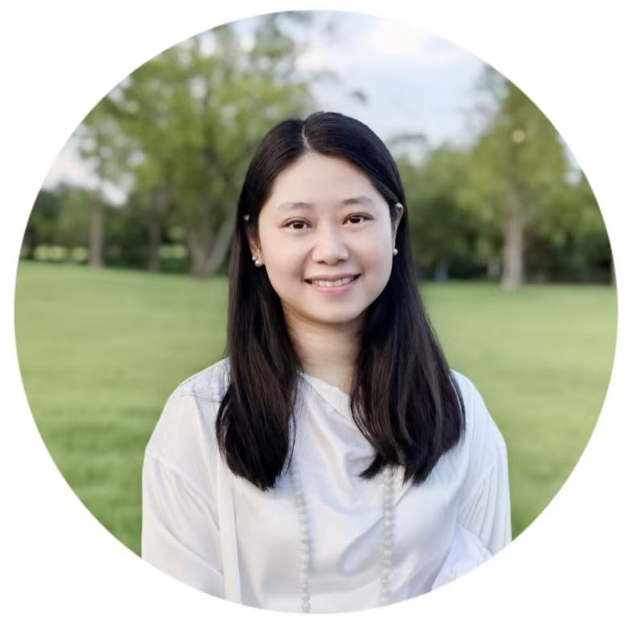
小团体顾问组组长 吕玥
重庆理工大学教师，中国心理学会注册系统注册督导师，国际认证萨提亚模式咨询师、培训师，萨提亚模式（中国）中方教员，英国塔维斯托克人类关系研究所认证团体动力师、认证组织发展与变革顾问、认证团体关系会议顾问，中国心理卫生协会团体专委会青年委员，中国社会工作教育协会伦理专委会理事。自2017年起多次担任团体关系会议成员，曾任文化翻译，多次担任会议顾问。多次担任会议顾问、顾问组长。
Yue Lyu
Teacher of Chongqing University of Technology, Registered Supervisor of Clinical Psychology Association Registration System Internationally Certified Satir Model Psychologist and Trainer Chinese Faculty Member of the Satir Model (BSCMC) .Certified Group Dynamics Practitioner of the Institute of Human Relations of Tavistock (UK),Certified Organisational Development and Change Consultant of the Institute of Human Relations of Tavistock (UK),Certified Group Relations Conference Consultant of the Institute of Human Relations of Tavistock (UK).Youth Committee Member of the Group Counseling Professional Committee, China Association for Mental Health Council Member of the Ethics Committee, China Association for Social Work Education. one of the founders of Chongqing Xin Sheng Ling Jie Health Management Consultancy Co.She has been a member of several Group Relations Conferences since 2017, and has worked as Cultural Interpreter and has served as Conference Consultant for several conferences. Served multiple times as a conference consultant and consultant team leader.

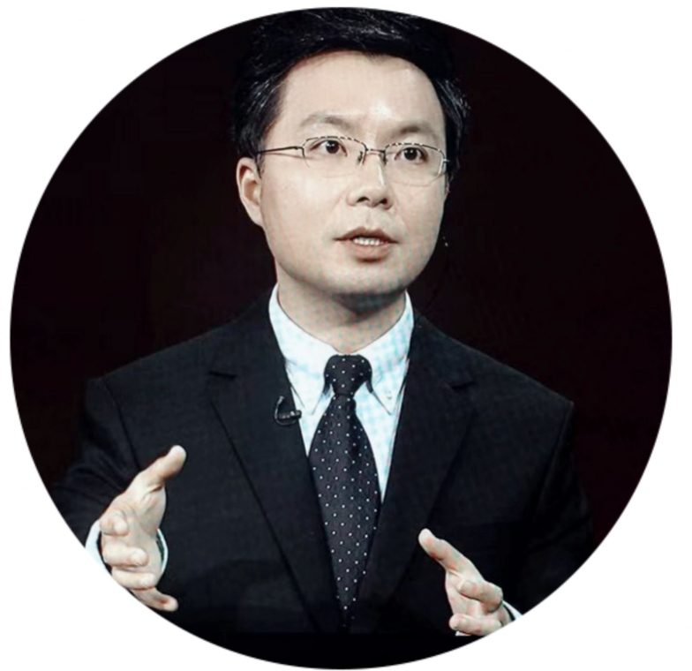
小团体顾问 王尔东
硕士，注册督导师（D-22-032），美国ABEPSGP认证心理剧导演（CP）和训练师（TEP），苏州大学心理人工智能协同创新中心主任，上海市第六人民医院精神心理科特聘专家，团体关系会议（GRC）顾问 、中国传统文化顾问。
Erdong Wang
MA, Registered Supervisor of Clinical Psychology (D-22-032). Certified Trainer, Educator and Practitioner (TEP) by ABEPSGP, USA. Director of the AI Psychology Collaborative Innovation Center of Suzhou University. Special Invited Expert, Department of Psychiatry and Psychology, Shanghai Sixth People's Hospital. Consultant of the Group Relations Conference (GRC), Consultant on Chinese Traditional Culture.

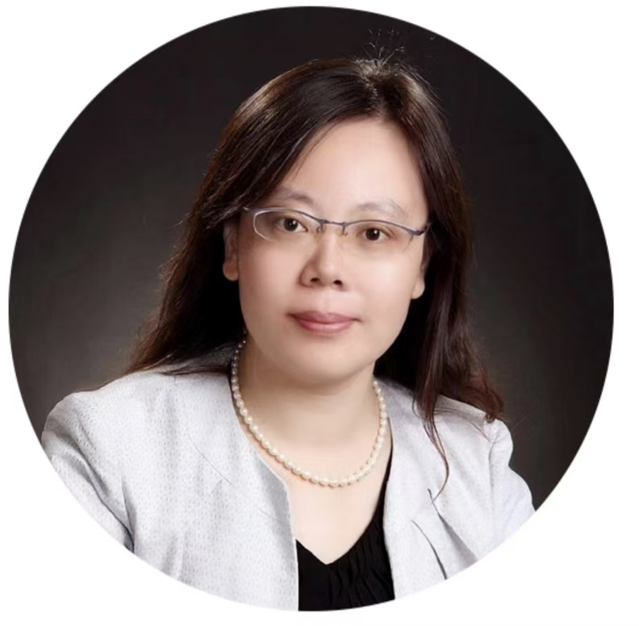
小团体顾问 孙晓峰
心理学硕士，人格心理和心理咨询博士肄业。动力取向心理咨询师。亚隆学院认证人际取向团体心理治疗师、督导师、培训师。团体关系顾问、组织顾问。曾在团体关系会议中担任成员（北京、芝加哥、香港、新奥尔良、Tavistock、青岛、上海）、文化翻译、受训顾问、行政人员、顾问、顾问组组长、副主任等角色。参加中国心理卫生协会团体心理辅导与治疗专业委员会、AKRI、CASSGO联合主办的团体顾问培训。Tavistock-China首届团体动力师和系统咨询与变革顾问。参加由Lionel Stapley教授指导的“小团体动力高级培训”并获得 IGO Consultancy 认证。
Xiaofeng Sun
Master of Psychological Counseling. Unfinished PhD of Personality and Counseling. Yalom Institute of Psychotherapy certified Interpersonal Approach Group Psychotherapist, Supervisor and Trainer. Group relations consultant, organizational consultant. She has been in GRC as a Member (Beijing, Chicago, Hong Kong, New Orleans, Tavistock, Qingdao, Shanghai), Cultural Translator, Consultant-in-training, Administrator, Consultant, Consultant Team Leader, Associate Director, etc. Trained by DGCGT, AKRI, CASSGO, Tavistock-China & Lionel Stapley.

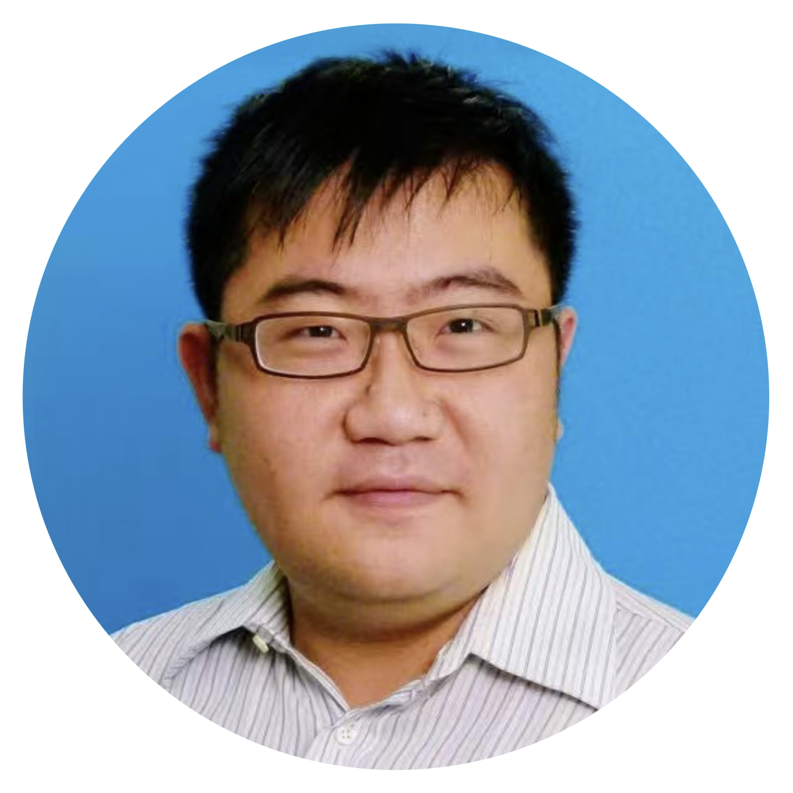
大团体顾问 颜子豪（新加坡）
颜子豪兼具中西医双重专业背景，是一位全科医生及持证针灸师，并拥有免疫学、传染病学与公共卫生研究背景。他致力于将具有文化敏感度的整体与整合性框架应用于个人及系统，曾在西新英格兰精神分析学院接受精神分析系统训练，持有耶鲁大学宗教研究硕士学位，并在加州完成了基于团体关系的跨宗教精神关怀临床牧关教育（CPE）驻院培训。他曾在国际团体关系会议中担任成员、顾问及行政人员。
Trained in both Western and Traditional Chinese Medicine, Victor Gan is a general practitioner and licensed acupuncturist with a background in immunology, infectious disease, and public health research. Applying culturally sensitive, integrative frameworks to individuals and systems, he completed scholarly training in psychoanalysis at the Western New England Psychoanalytic Institute, holds a Master of Arts in Religion from Yale, and completed a group relations-based Clinical Pastoral Education (CPE) residency in interfaith spiritual care in California. He has participated in Group Relations Conferences internationally as a member, consultant, and administrator.

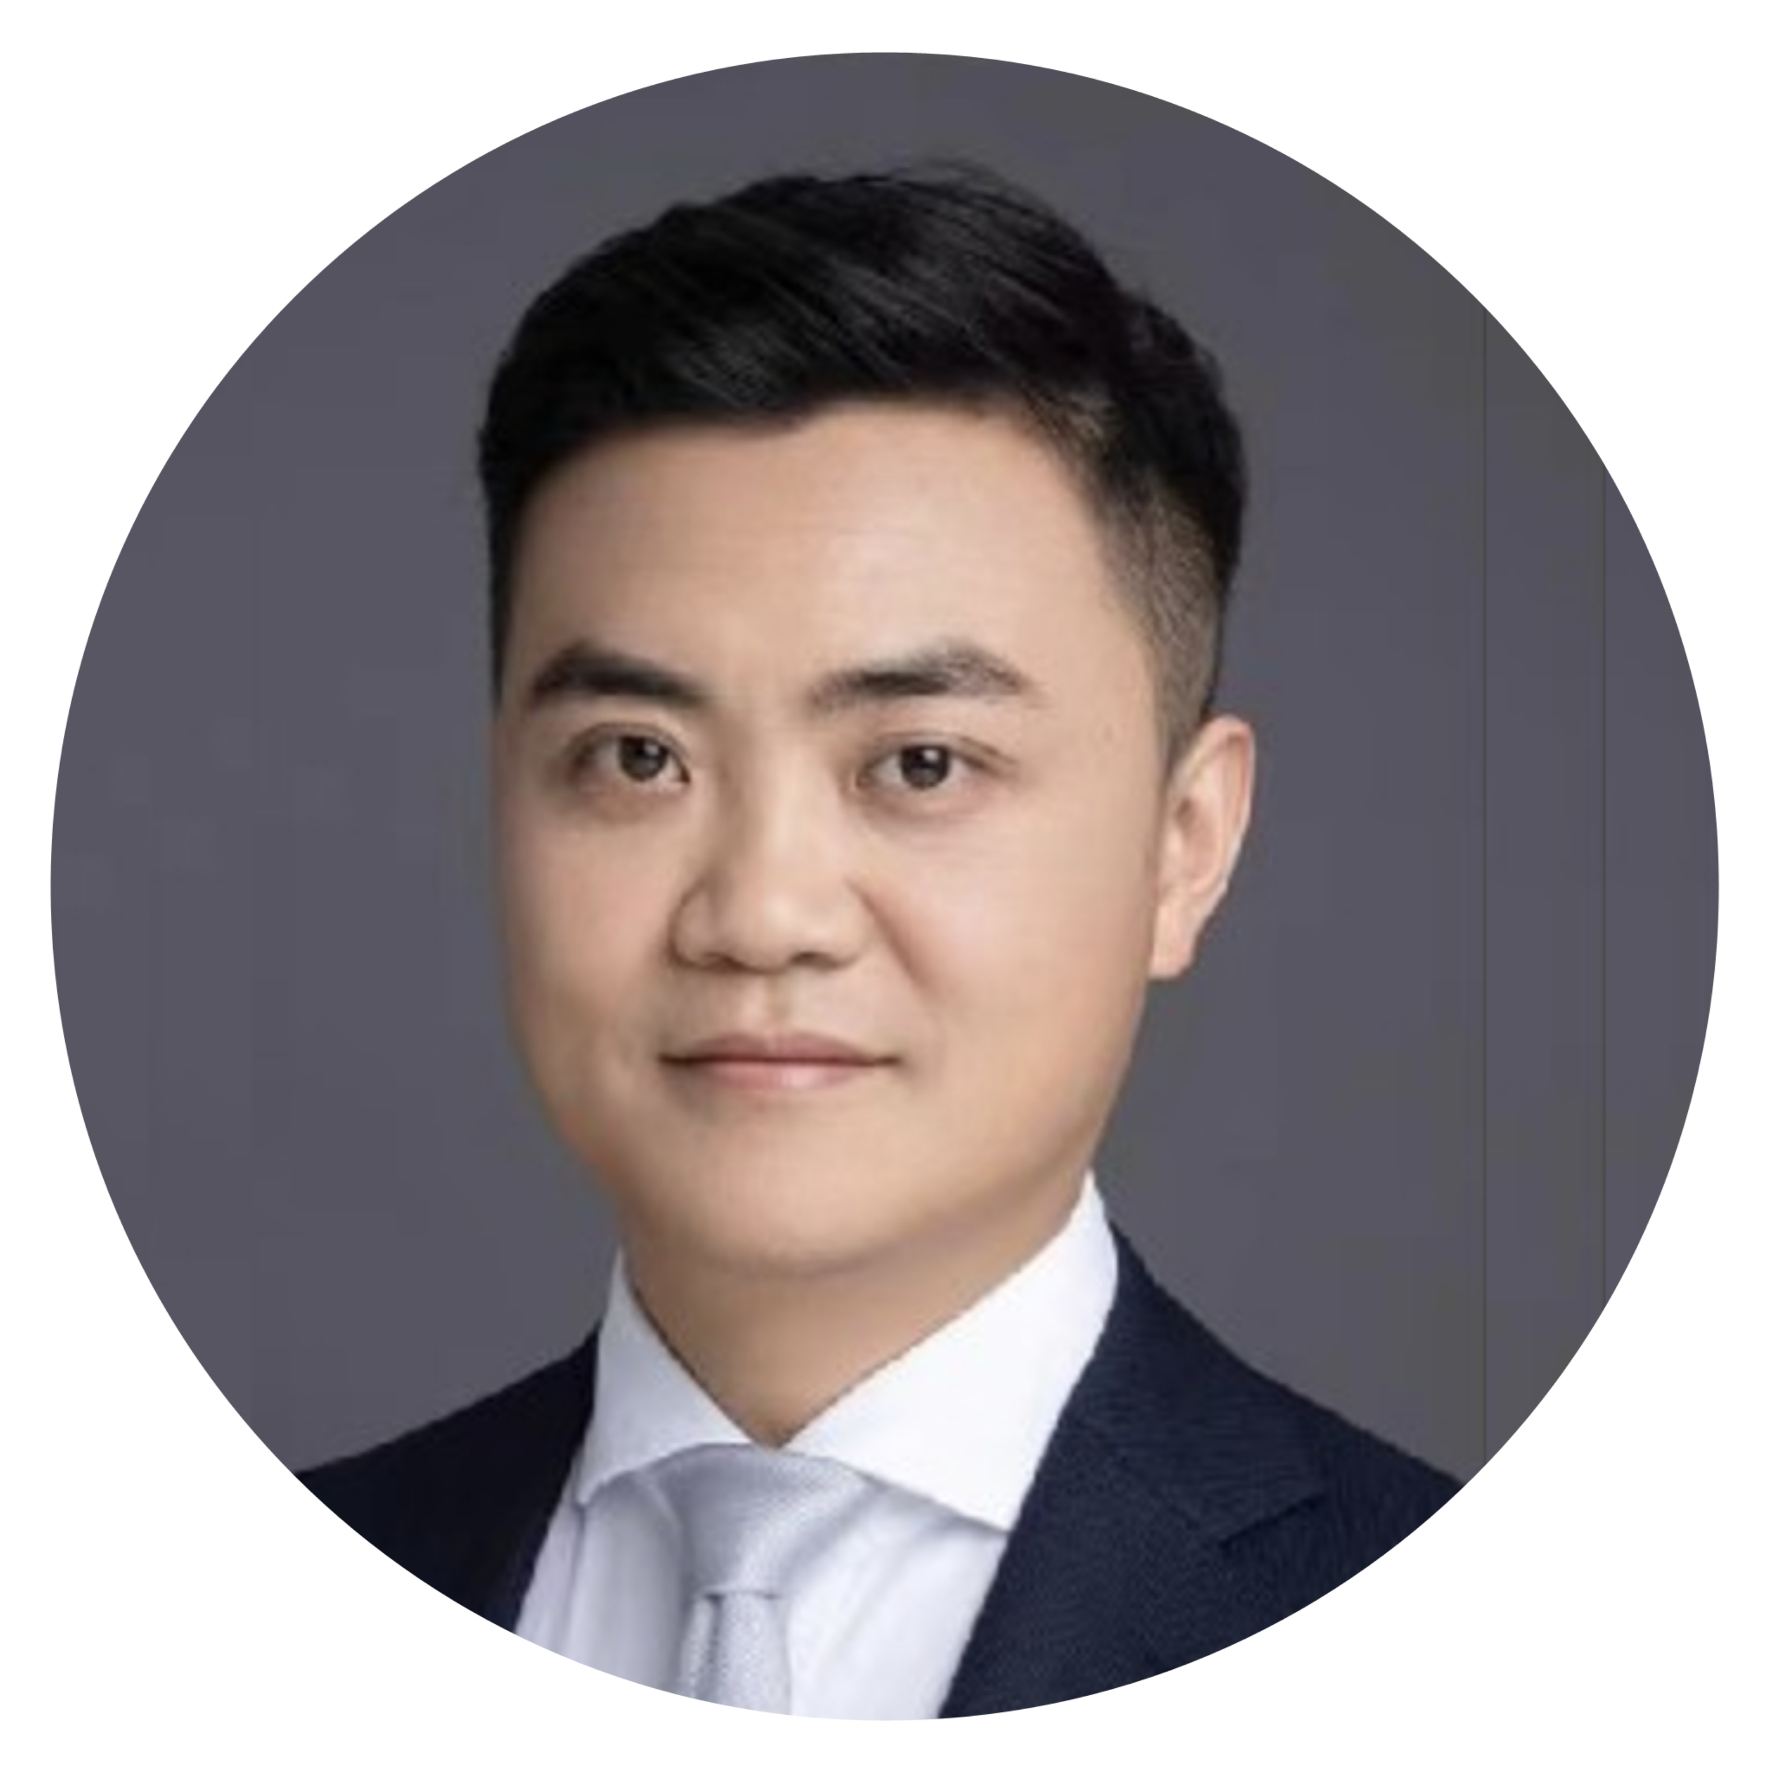
小团体顾问 茆丁
临床执业医师，心理咨询师，EMDR-CHINA秘书，EMDR（眼动脱敏与再加工）心理创伤治疗督导师。千江心理咨询（上海）事务所心理咨询督导，中国心理卫生协会团体辅导与治疗专业委员会第四届委员，中国心理卫生协会心理治疗与心理咨询专委会第八届青年委员，中国性学会性心理分会第八届委员，上海市徐汇区心理咨询行业工会联合会副主席。塔维斯托克研究所认证的团体关系会议顾问，贝曼萨提亚管理中心认证的培训师，欧文亚隆研究院认证的团体咨询督导师，TF-CBT（聚焦创伤的认知行为治疗）认证提供者。
Mao DingLicensed Clinical Physician | Psychological Counselor | Secretary of EMDR-China | EMDR (Eye Movement Desensitization and Reprocessing) Trauma Therapy SupervisorClinical Supervision Consultant, Qianjiang Psychological Counseling (Shanghai) OfficeMember of the 4th Committee of the Group Counseling and Therapy Professional Committee, Chinese Association for Mental HealthMember of the 8th Youth Committee of the Psychotherapy and Psychological Counseling Professional Committee, Chinese Association for Mental HealthMember of the 8th Committee of the Sexual Psychology Branch, Chinese Sexology AssociationVice Chairperson of the Shanghai Xuhui District Psychological Counseling Industry Union FederationCertified Group Relations Conference Consultant, Tavistock InstituteCertified Trainer, Baiman Satir Management CenterCertified Group Counseling Supervisor, Yalom InstituteCertified Provider of TF-CBT (Trauma-Focused Cognitive Behavioral Therapy）。


行政 张杲霞
心理咨询师，童话心语（北京）教育咨询创始人。十年跨文化领域工作经验，曾任通用电气石油天然气集团渠道经理。CASSGO会员、运营委员会成员、GRC团体关系受训顾问，十年+个体&团体咨询经验。多个学校、社区、企业合作心理咨询师。
Zhang Gaoxia
Psychological Counselor，Founder of Tonghua Xinyu (Beijing) Education & Consulting。With ten years of cross-cultural working experience. Former Channel Manager of GE Oil & Gas Group.Member of CASSGO and its Operations Committee, Trained Consultant for Group Relations Conferences (GRC).Over ten years of experience in individual and group psychotherapy.Serving as a cooperating psychological counselor for multiple schools, communities and enterprises.


行政 周湘
渔歌轻飏心理咨询工作室创办与负责人，资深心理咨询师，督导师。全职从业16年，细腻个案咨询13000+小节，团体咨询及团体实践2000+小时，提供心理咨询师个案督导加团体督导6000+小节。以成员身份参加2018年北京团体关系会议，以受训顾问身份参加2025年北京团体关系会议，及多次参加团体关系工作坊。
主要受训：第六届中德班精神分析连续培训督导组结业（2014-2016年），第五届中挪班精神分析连续培训团体组结业（2018-2022年），首届中美短程家庭治疗连续培训结业（2019-2022年，美国家庭心智研究所（MRI）短程治疗中心与上海市精神卫生中心举办）。华南区中德模式精神分析连续三年培训（2009-2011年）。
Zhou Xiang: Founder and Director of Yuge Qingyang Counseling Studio; Senior Counseling Psychologist and Clinical Supervisor. She has practiced full-time for 16 years, with over 13,000 individual therapy sessions, 2,000+ hours of group therapy and group practice, and more than 6,000 hours of individual and group supervision for counselors-in-training.Participated in the 2018 Beijing Group Relations Conference as a member, and in the 2025 Beijing Group Relations Conference as a Consultant-in-Training; has also attended multiple Group Relations workshops.
Her core training includes:The 6th China-Germany Psychodynamic Psychotherapy Advanced Training Program (Supervision Track), completed 2014–2016;The 5th China-Norway Psychodynamic Psychotherapy Continuous Training Program (Group Therapy Track), completed 2018–2022;The 1st China-US Brief Family Therapy Continuous Training Program (2019–2022), jointly organized by the Mental Research Institute (MRI), USA, and the Shanghai Mental Health Center;The 3-Year South China Psychodynamic Psychotherapy Training Program (China-Germany Model), completed 2009–2011.

